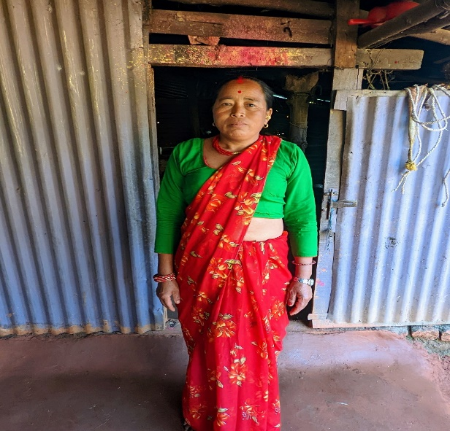

Khop Kumari Shrestha -Godawari women’s group
Through WPD, she purchased a buffalo and then the buffalo had two calves. Before renew, she only had small rice plots but the access to loans has helped to diversify her crops and livestock. “I’m very happy, we have been supported”.

